# Import Libraries

#Importing and Installing Required Modules and Libraries  
!pip install tensorflow  
!pip install basic_image_eda  
import os  
import pandas as pd  
import numpy as np  
import matplotlib.pyplot as plt  
import matplotlib.colors as mcolors  
import seaborn as sns  
sns.set_theme(style="whitegrid")  
import cv2  
import sys  
from re import sub  
import tensorflow as tf  
from tensorflow.keras import metrics  
from tensorflow.keras.models import Sequential  
from tensorflow.keras.layers import BatchNormalization  
from tensorflow.keras.layers import Conv2D  
from tensorflow.keras.layers import MaxPooling2D  
from tensorflow.keras.layers import Activation, Flatten, Dropout, Dense  
from tensorflow.keras.optimizers import Adam  
from tensorflow.keras.preprocessing import image  
from tensorflow.keras import models  
from tensorflow.keras.preprocessing import image_dataset_from_directory

OUTPUT

Requirement already satisfied: tensorflow in c:\users\Abhishek\appdata\local\programs\python\python39\lib\site-packages (2.6.0)  
Requirement already satisfied: opt-einsum~=3.3.0 in c:\users\Abhishek\appdata\local\programs\python\python39\lib\site-packages (from tensorflow) (3.3.0)  
Requirement already satisfied: astunparse~=1.6.3 in c:\users\Abhishek\appdata\local\programs\python\python39\lib\site-packages (from tensorflow) (1.6.3)  
Requirement already satisfied: typing-extensions~=3.7.4 in c:\users\Abhishek\appdata\local\programs\python\python39\lib\site-packages (from tensorflow) (3.7.4.3)  
Requirement already satisfied: grpcio<2.0,>=1.37.0 in c:\users\Abhishek\appdata\local\programs\python\python39\lib\site-packages (from tensorflow) (1.39.0)  
Requirement already satisfied: keras-preprocessing~=1.1.2 in c:\users\Abhishek\appdata\local\programs\python\python39\lib\site-packages (from tensorflow) (1.1.2)  
Requirement already satisfied: numpy~=1.19.2 in c:\users\Abhishek\appdata\local\programs\python\python39\lib\site-packages (from tensorflow) (1.19.5)  
Requirement already satisfied: tensorflow-estimator~=2.6 in c:\users\Abhishek\appdata\local\programs\python\python39\lib\site-packages (from tensorflow) (2.6.0)  
Requirement already satisfied: h5py~=3.1.0 in c:\users\Abhishek\appdata\local\programs\python\python39\lib\site-packages (from tensorflow) (3.1.0)  
Requirement already satisfied: six~=1.15.0 in c:\users\Abhishek\appdata\local\programs\python\python39\lib\site-packages (from tensorflow) (1.15.0)  
Requirement already satisfied: clang~=5.0 in c:\users\Abhishek\appdata\local\programs\python\python39\lib\site-packages (from tensorflow) (5.0)  
Requirement already satisfied: wrapt~=1.12.1 in c:\users\Abhishek\appdata\local\programs\python\python39\lib\site-packages (from tensorflow) (1.12.1)  
Requirement already satisfied: wheel~=0.35 in c:\users\Abhishek\appdata\local\programs\python\python39\lib\site-packages (from tensorflow) (0.37.0)  
Requirement already satisfied: flatbuffers~=1.12.0 in c:\users\Abhishek\appdata\local\programs\python\python39\lib\site-packages (from tensorflow) (1.12)  
Requirement already satisfied: google-pasta~=0.2 in c:\users\Abhishek\appdata\local\programs\python\python39\lib\site-packages (from tensorflow) (0.2.0)  
Requirement already satisfied: gast==0.4.0 in c:\users\Abhishek\appdata\local\programs\python\python39\lib\site-packages (from tensorflow) (0.4.0)  
Requirement already satisfied: termcolor~=1.1.0 in c:\users\Abhishek\appdata\local\programs\python\python39\lib\site-packages (from tensorflow) (1.1.0)  
Requirement already satisfied: protobuf>=3.9.2 in c:\users\Abhishek\appdata\local\programs\python\python39\lib\site-packages (from tensorflow) (3.17.3)  
Requirement already satisfied: absl-py~=0.10 in c:\users\Abhishek\appdata\local\programs\python\python39\lib\site-packages (from tensorflow) (0.13.0)  
Requirement already satisfied: tensorboard~=2.6 in c:\users\Abhishek\appdata\local\programs\python\python39\lib\site-packages (from tensorflow) (2.6.0)  
Requirement already satisfied: keras~=2.6 in c:\users\Abhishek\appdata\local\programs\python\python39\lib\site-packages (from tensorflow) (2.6.0)  
Requirement already satisfied: google-auth<2,>=1.6.3 in c:\users\Abhishek\appdata\local\programs\python\python39\lib\site-packages (from tensorboard~=2.6->tensorflow) (1.35.0)  
Requirement already satisfied: tensorboard-data-server<0.7.0,>=0.6.0 in c:\users\Abhishek\appdata\local\programs\python\python39\lib\site-packages (from tensorboard~=2.6->tensorflow) (0.6.1)  
Requirement already satisfied: markdown>=2.6.8 in c:\users\Abhishek\appdata\local\programs\python\python39\lib\site-packages (from tensorboard~=2.6->tensorflow) (3.3.4)  
Requirement already satisfied: werkzeug>=0.11.15 in c:\users\Abhishek\appdata\local\programs\python\python39\lib\site-packages (from tensorboard~=2.6->tensorflow) (2.0.1)  
Requirement already satisfied: setuptools>=41.0.0 in c:\users\Abhishek\appdata\local\programs\python\python39\lib\site-packages (from tensorboard~=2.6->tensorflow) (56.0.0)  
Requirement already satisfied: tensorboard-plugin-wit>=1.6.0 in c:\users\Abhishek\appdata\local\programs\python\python39\lib\site-packages (from tensorboard~=2.6->tensorflow) (1.8.0)  
Requirement already satisfied: google-auth-oauthlib<0.5,>=0.4.1 in c:\users\Abhishek\appdata\local\programs\python\python39\lib\site-packages (from tensorboard~=2.6->tensorflow) (0.4.5)  
Requirement already satisfied: requests<3,>=2.21.0 in c:\users\Abhishek\appdata\local\programs\python\python39\lib\site-packages (from tensorboard~=2.6->tensorflow) (2.26.0)  
Requirement already satisfied: pyasn1-modules>=0.2.1 in c:\users\Abhishek\appdata\local\programs\python\python39\lib\site-packages (from google-auth<2,>=1.6.3->tensorboard~=2.6->tensorflow) (0.2.8)  
Requirement already satisfied: rsa<5,>=3.1.4 in c:\users\Abhishek\appdata\local\programs\python\python39\lib\site-packages (from google-auth<2,>=1.6.3->tensorboard~=2.6->tensorflow) (4.7.2)  
Requirement already satisfied: cachetools<5.0,>=2.0.0 in c:\users\Abhishek\appdata\local\programs\python\python39\lib\site-packages (from google-auth<2,>=1.6.3->tensorboard~=2.6->tensorflow) (4.2.2)  
Requirement already satisfied: requests-oauthlib>=0.7.0 in c:\users\Abhishek\appdata\local\programs\python\python39\lib\site-packages (from google-auth-oauthlib<0.5,>=0.4.1->tensorboard~=2.6->tensorflow) (1.3.0)  
Requirement already satisfied: pyasn1<0.5.0,>=0.4.6 in c:\users\Abhishek\appdata\local\programs\python\python39\lib\site-packages (from pyasn1-modules>=0.2.1->google-auth<2,>=1.6.3->tensorboard~=2.6->tensorflow) (0.4.8)  
Requirement already satisfied: certifi>=2017.4.17 in c:\users\Abhishek\appdata\local\programs\python\python39\lib\site-packages (from requests<3,>=2.21.0->tensorboard~=2.6->tensorflow) (2021.5.30)  
Requirement already satisfied: urllib3<1.27,>=1.21.1 in c:\users\Abhishek\appdata\local\programs\python\python39\lib\site-packages (from requests<3,>=2.21.0->tensorboard~=2.6->tensorflow) (1.26.6)  
Requirement already satisfied: idna<4,>=2.5 in c:\users\Abhishek\appdata\local\programs\python\python39\lib\site-packages (from requests<3,>=2.21.0->tensorboard~=2.6->tensorflow) (3.2)  
Requirement already satisfied: charset-normalizer~=2.0.0 in c:\users\Abhishek\appdata\local\programs\python\python39\lib\site-packages (from requests<3,>=2.21.0->tensorboard~=2.6->tensorflow) (2.0.4)  
Requirement already satisfied: oauthlib>=3.0.0 in c:\users\Abhishek\appdata\local\programs\python\python39\lib\site-packages (from requests-oauthlib>=0.7.0->google-auth-oauthlib<0.5,>=0.4.1->tensorboard~=2.6->tensorflow) (3.1.1)  
Requirement already satisfied: basic_image_eda in c:\users\Abhishek\appdata\local\programs\python\python39\lib\site-packages (0.0.3)

# Load Dataset

data_dir = r"Downloads/plantvillage-dataset/color/"

# Sample Image

img = plt.imread(data_dir+"Apple___Apple_scab/00075aa8-d81a-4184-8541-b692b78d398a___FREC_Scab 3335.JPG")  
plt.imshow(img)

<matplotlib.image.AxesImage at 0x1d4240aba00>

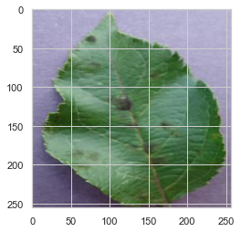

# Exploratory Data Analysis

category_count = []  
  
for root, dirs, files in os.walk(data_dir):  
 for dir_path in dirs:  
 category_count.append((dir_path, len(os.listdir(root+os.sep+dir_path))))  
count_df = pd.DataFrame(category_count, columns=['Category', 'Count'])  
count_df.head(10)

Category Count  
0 Apple___Apple_scab 630  
1 Apple___Black_rot 621  
2 Apple___Cedar_apple_rust 275  
3 Apple___healthy 1645  
4 Blueberry___healthy 1502  
5 Cherry_(including_sour)___healthy 854  
6 Cherry_(including_sour)___Powdery_mildew 1052  
7 Corn_(maize)___Cercospora_leaf_spot Gray_leaf_... 513  
8 Corn_(maize)___Common_rust_ 1192  
9 Corn_(maize)___healthy 1162

total_images = count_df['Count'].sum()  
total_images

54305

# Data Visualization by Category

count_df = count_df.sort_values(by='Count', ascending=False)  
plt.figure(figsize=(20,20))  
sns.barplot(x="Count", y="Category", data=count_df)  
plt.plot()

[]

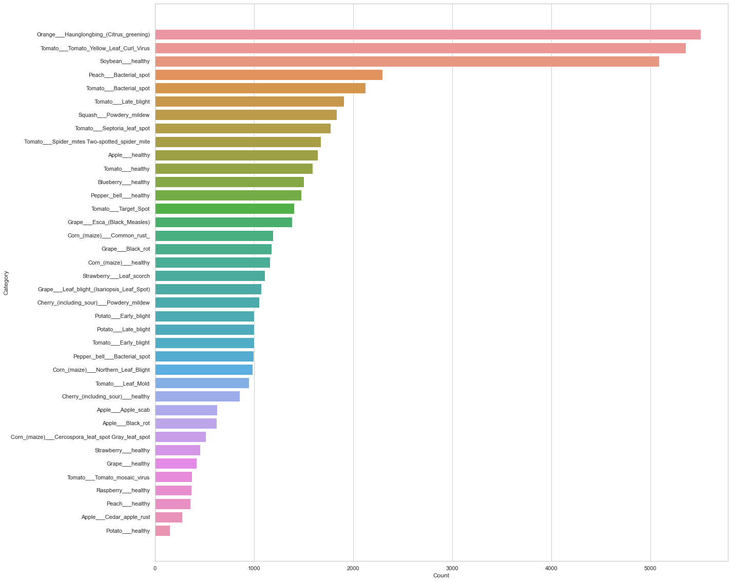

# Counting the Healthy Plants

healthy_images_count = count_df[count_df['Category'].str.endswith("healthy")]['Count'].sum()  
healthy_images_count

15084

# Counting he Unhealthy Plant by Substracting Healthy from Total Datasets

disease_images_count = total_images - healthy_images_count  
disease_images_count

39221

# Ploting Graph of Healthy and Unhealthy Plants

temp_df = pd.DataFrame(data=[("Unhealthy", disease_images_count), ("Healthy", healthy_images_count)], columns=['Category', 'Count'])  
sns.barplot(y="Count",x="Category", data=temp_df)  
plt.plot()

[]

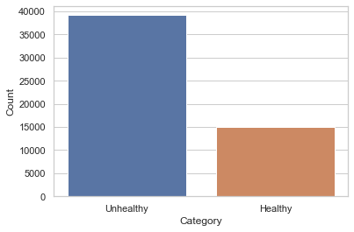

# Data Augmentation and Pre-processing

BATCH_SIZE = 32  
IMG_SIZE = (240, 240)

train_dataset = image_dataset_from_directory(data_dir,  
 shuffle=True,  
 label_mode = 'categorical',  
 validation_split = 0.2,  
 batch_size=BATCH_SIZE,  
 seed = 42,  
 subset = "training",  
 image_size=IMG_SIZE)  
  
validation_dataset = image_dataset_from_directory(data_dir,  
 shuffle=True,  
 label_mode = 'categorical',  
 validation_split = 0.2,  
 batch_size=BATCH_SIZE,  
 seed = 42,  
 subset = "validation",  
 image_size=IMG_SIZE)

Found 54305 files belonging to 38 classes.  
Using 43444 files for training.  
Found 54305 files belonging to 38 classes.  
Using 10861 files for validation.

class_names = train_dataset.class_names  
num_classes = len(class_names)  
for i in range(1, num_classes + 1):  
 print(str(i) + ". ", class_names[i - 1])

1. Apple___Apple_scab  
2. Apple___Black_rot  
3. Apple___Cedar_apple_rust  
4. Apple___healthy  
5. Blueberry___healthy  
6. Cherry_(including_sour)___Powdery_mildew  
7. Cherry_(including_sour)___healthy  
8. Corn_(maize)___Cercospora_leaf_spot Gray_leaf_spot  
9. Corn_(maize)___Common_rust_  
10. Corn_(maize)___Northern_Leaf_Blight  
11. Corn_(maize)___healthy  
12. Grape___Black_rot  
13. Grape___Esca_(Black_Measles)  
14. Grape___Leaf_blight_(Isariopsis_Leaf_Spot)  
15. Grape___healthy  
16. Orange___Haunglongbing_(Citrus_greening)  
17. Peach___Bacterial_spot  
18. Peach___healthy  
19. Pepper,_bell___Bacterial_spot  
20. Pepper,_bell___healthy  
21. Potato___Early_blight  
22. Potato___Late_blight  
23. Potato___healthy  
24. Raspberry___healthy  
25. Soybean___healthy  
26. Squash___Powdery_mildew  
27. Strawberry___Leaf_scorch  
28. Strawberry___healthy  
29. Tomato___Bacterial_spot  
30. Tomato___Early_blight  
31. Tomato___Late_blight  
32. Tomato___Leaf_Mold  
33. Tomato___Septoria_leaf_spot  
34. Tomato___Spider_mites Two-spotted_spider_mite  
35. Tomato___Target_Spot  
36. Tomato___Tomato_Yellow_Leaf_Curl_Virus  
37. Tomato___Tomato_mosaic_virus  
38. Tomato___healthy

val_batches = tf.data.experimental.cardinality(validation_dataset)  
test_dataset = validation_dataset.take(val_batches // 5)  
validation_dataset = validation_dataset.skip(val_batches // 5)  
  
print('Number of validation batches: %d' % tf.data.experimental.cardinality(validation_dataset))  
print('Number of test batches: %d' % tf.data.experimental.cardinality(test_dataset))

Number of validation batches: 272  
Number of test batches: 68

AUTOTUNE = tf.data.AUTOTUNE  
train_dataset = train_dataset.prefetch(buffer_size=AUTOTUNE)  
validation_dataset = validation_dataset.prefetch(buffer_size=AUTOTUNE)  
test_dataset = test_dataset.prefetch(buffer_size=AUTOTUNE)

# added augmentations  
data_augmentation = tf.keras.Sequential([  
 tf.keras.layers.experimental.preprocessing.RandomFlip('horizontal'),  
 tf.keras.layers.experimental.preprocessing.RandomRotation(0.2),  
])

for image, _ in train_dataset.take(1):  
 plt.figure(figsize=(10, 10))  
 first_image = image[0]  
 for i in range(9):  
 ax = plt.subplot(3, 3, i + 1)  
 augmented_image = data_augmentation(tf.expand_dims(first_image, 0))  
 plt.imshow(augmented_image[0] / 255)  
 plt.axis('off')

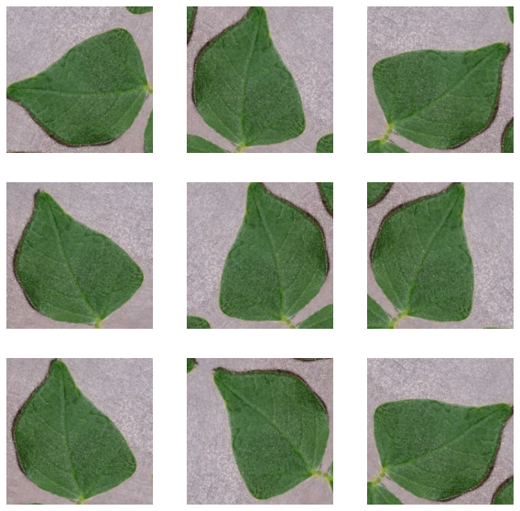

## Metrics and Plotting functions

def plot_metrics(history):  
 colors = ['b', 'g', 'r', 'c', 'm', 'y', 'k', 'w']  
 metrics = ['loss', 'auc', 'precision', 'recall']  
 plt.figure(figsize=(20,10))  
 for n, metric in enumerate(metrics):  
 name = metric.replace("_"," ").capitalize()  
 plt.subplot(2,2,n+1)  
 plt.plot(history.epoch, history.history[metric], color=colors[0], label='Train')  
 plt.plot(history.epoch, history.history['val_'+metric],  
 color=colors[0], linestyle="--", label='Val')  
 plt.xlabel('Epoch')  
 plt.ylabel(name)  
 if metric == 'loss':  
 plt.ylim([0, plt.ylim()[1]])  
 elif metric == 'auc':  
 plt.ylim([0.8,1])  
 else:  
 plt.ylim([0,1])  
  
 plt.legend()

METRICS = [  
 metrics.TruePositives(name='tp'),  
 metrics.FalsePositives(name='fp'),  
 metrics.TrueNegatives(name='tn'),  
 metrics.FalseNegatives(name='fn'),   
 metrics.CategoricalAccuracy(name='accuracy'),  
 metrics.Precision(name='precision'),  
 metrics.Recall(name='recall'),  
 metrics.AUC(name='auc')  
]

## Load and compile model

IMG_SHAPE = IMG_SIZE + (3,)

preprocess_input = tf.keras.applications.inception_resnet_v2.preprocess_input

base_model = tf.keras.applications.InceptionResNetV2(  
 include_top=False,  
 weights="imagenet",  
 input_shape=IMG_SHAPE,  
 )

Downloading data from https://storage.googleapis.com/tensorflow/keras-applications/inception_resnet_v2/inception_resnet_v2_weights_tf_dim_ordering_tf_kernels_notop.h5  
219062272/219055592 [==============================] - 1s 0us/step  
219070464/219055592 [==============================] - 1s 0us/step

image_batch, label_batch = next(iter(train_dataset))  
feature_batch = base_model(image_batch)  
print(feature_batch.shape)

(32, 6, 6, 1536)

base_model.trainable = False

global_average_layer = tf.keras.layers.GlobalAveragePooling2D()  
feature_batch_average = global_average_layer(feature_batch)  
  
print(feature_batch_average.shape)

(32, 1536)

prediction_layer = tf.keras.layers.Dense(num_classes, activation="softmax")  
prediction_batch = prediction_layer(feature_batch_average)  
print(prediction_batch.shape)

(32, 38)

inputs = tf.keras.Input(shape=(240, 240, 3))  
x = data_augmentation(inputs)  
x = preprocess_input(x)  
x = base_model(x, training=False)  
x = global_average_layer(x)  
x = tf.keras.layers.Dropout(0.2)(x)  
outputs = prediction_layer(x)  
model = tf.keras.Model(inputs, outputs)

base_learning_rate = 0.001  
model.compile(optimizer=tf.keras.optimizers.Adam(lr=base_learning_rate),  
 loss=tf.keras.losses.CategoricalCrossentropy(from_logits=True),  
 metrics=METRICS)

C:\Users\Abhishek\AppData\Local\Programs\Python\Python39\lib\site-packages\keras\optimizer_v2\optimizer_v2.py:355: UserWarning: The `lr` argument is deprecated, use `learning_rate` instead.  
 warnings.warn(

model.summary()

Model: "model"  
_________________________________________________________________  
Layer (type) Output Shape Param #   
=================================================================  
input_2 (InputLayer) [(None, 240, 240, 3)] 0   
_________________________________________________________________  
sequential (Sequential) (None, 240, 240, 3) 0   
_________________________________________________________________  
tf.math.truediv (TFOpLambda) (None, 240, 240, 3) 0   
_________________________________________________________________  
tf.math.subtract (TFOpLambda (None, 240, 240, 3) 0   
_________________________________________________________________  
inception_resnet_v2 (Functio (None, 6, 6, 1536) 54336736   
_________________________________________________________________  
global_average_pooling2d (Gl (None, 1536) 0   
_________________________________________________________________  
dropout (Dropout) (None, 1536) 0   
_________________________________________________________________  
dense (Dense) (None, 38) 58406   
=================================================================  
Total params: 54,395,142  
Trainable params: 58,406  
Non-trainable params: 54,336,736  
_________________________________________________________________

# Training, Validation and Testing

Before tuning

initial_epochs = 10

history = model.fit(train_dataset,  
 epochs=initial_epochs,  
 validation_data=validation_dataset)

Epoch 1/10

C:\Users\Abhishek\AppData\Local\Programs\Python\Python39\lib\site-packages\keras\backend.py:4846: UserWarning: "`categorical_crossentropy` received `from_logits=True`, but the `output` argument was produced by a sigmoid or softmax activation and thus does not represent logits. Was this intended?"  
 warnings.warn(

1358/1358 [==============================] - 3620s 3s/step - loss: 0.8491 - tp: 27133.0000 - fp: 2299.0000 - tn: 1605129.0000 - fn: 16311.0000 - accuracy: 0.7646 - precision: 0.9219 - recall: 0.6246 - auc: 0.9872 - val_loss: 0.4727 - val_tp: 6783.0000 - val_fp: 552.0000 - val_tn: 320793.0000 - val_fn: 1902.0000 - val_accuracy: 0.8558 - val_precision: 0.9247 - val_recall: 0.7810 - val_auc: 0.9963  
Epoch 2/10  
1358/1358 [==============================] - 3638s 3s/step - loss: 0.4329 - tp: 35232.0000 - fp: 2742.0000 - tn: 1604686.0000 - fn: 8212.0000 - accuracy: 0.8704 - precision: 0.9278 - recall: 0.8110 - auc: 0.9959 - val_loss: 0.3538 - val_tp: 7359.0000 - val_fp: 482.0000 - val_tn: 320863.0000 - val_fn: 1326.0000 - val_accuracy: 0.8940 - val_precision: 0.9385 - val_recall: 0.8473 - val_auc: 0.9975  
Epoch 3/10  
1358/1358 [==============================] - 3650s 3s/step - loss: 0.3622 - tp: 36849.0000 - fp: 2775.0000 - tn: 1604653.0000 - fn: 6595.0000 - accuracy: 0.8884 - precision: 0.9300 - recall: 0.8482 - auc: 0.9967 - val_loss: 0.2919 - val_tp: 7650.0000 - val_fp: 448.0000 - val_tn: 320897.0000 - val_fn: 1035.0000 - val_accuracy: 0.9108 - val_precision: 0.9447 - val_recall: 0.8808 - val_auc: 0.9979  
Epoch 4/10  
1358/1358 [==============================] - 3660s 3s/step - loss: 0.3282 - tp: 37482.0000 - fp: 2765.0000 - tn: 1604663.0000 - fn: 5962.0000 - accuracy: 0.8968 - precision: 0.9313 - recall: 0.8628 - auc: 0.9969 - val_loss: 0.2575 - val_tp: 7722.0000 - val_fp: 445.0000 - val_tn: 320900.0000 - val_fn: 963.0000 - val_accuracy: 0.9162 - val_precision: 0.9455 - val_recall: 0.8891 - val_auc: 0.9983  
Epoch 5/10  
1358/1358 [==============================] - 3684s 3s/step - loss: 0.3023 - tp: 38110.0000 - fp: 2666.0000 - tn: 1604762.0000 - fn: 5334.0000 - accuracy: 0.9038 - precision: 0.9346 - recall: 0.8772 - auc: 0.9969 - val_loss: 0.2475 - val_tp: 7813.0000 - val_fp: 414.0000 - val_tn: 320931.0000 - val_fn: 872.0000 - val_accuracy: 0.9239 - val_precision: 0.9497 - val_recall: 0.8996 - val_auc: 0.9979  
Epoch 6/10  
1358/1358 [==============================] - 3653s 3s/step - loss: 0.2900 - tp: 38290.0000 - fp: 2682.0000 - tn: 1604746.0000 - fn: 5154.0000 - accuracy: 0.9066 - precision: 0.9345 - recall: 0.8814 - auc: 0.9972 - val_loss: 0.2138 - val_tp: 7911.0000 - val_fp: 395.0000 - val_tn: 320950.0000 - val_fn: 774.0000 - val_accuracy: 0.9308 - val_precision: 0.9524 - val_recall: 0.9109 - val_auc: 0.9985  
Epoch 7/10  
1358/1358 [==============================] - 3658s 3s/step - loss: 0.2796 - tp: 38590.0000 - fp: 2675.0000 - tn: 1604753.0000 - fn: 4854.0000 - accuracy: 0.9100 - precision: 0.9352 - recall: 0.8883 - auc: 0.9969 - val_loss: 0.2114 - val_tp: 7898.0000 - val_fp: 402.0000 - val_tn: 320943.0000 - val_fn: 787.0000 - val_accuracy: 0.9308 - val_precision: 0.9516 - val_recall: 0.9094 - val_auc: 0.9988  
Epoch 8/10  
1358/1358 [==============================] - 3640s 3s/step - loss: 0.2718 - tp: 38742.0000 - fp: 2683.0000 - tn: 1604745.0000 - fn: 4702.0000 - accuracy: 0.9112 - precision: 0.9352 - recall: 0.8918 - auc: 0.9971 - val_loss: 0.2089 - val_tp: 7940.0000 - val_fp: 390.0000 - val_tn: 320955.0000 - val_fn: 745.0000 - val_accuracy: 0.9337 - val_precision: 0.9532 - val_recall: 0.9142 - val_auc: 0.9984  
Epoch 9/10  
1358/1358 [==============================] - 3630s 3s/step - loss: 0.2665 - tp: 38808.0000 - fp: 2756.0000 - tn: 1604672.0000 - fn: 4636.0000 - accuracy: 0.9123 - precision: 0.9337 - recall: 0.8933 - auc: 0.9972 - val_loss: 0.2334 - val_tp: 7872.0000 - val_fp: 467.0000 - val_tn: 320878.0000 - val_fn: 813.0000 - val_accuracy: 0.9247 - val_precision: 0.9440 - val_recall: 0.9064 - val_auc: 0.9977  
Epoch 10/10  
1358/1358 [==============================] - 3655s 3s/step - loss: 0.2687 - tp: 38918.0000 - fp: 2738.0000 - tn: 1604690.0000 - fn: 4526.0000 - accuracy: 0.9139 - precision: 0.9343 - recall: 0.8958 - auc: 0.9968 - val_loss: 0.2161 - val_tp: 7949.0000 - val_fp: 425.0000 - val_tn: 320920.0000 - val_fn: 736.0000 - val_accuracy: 0.9313 - val_precision: 0.9492 - val_recall: 0.9153 - val_auc: 0.9974

After tuning

base_model.trainable = True

# Let's take a look to see how many layers are in the base model  
print("Number of layers in the base model: ", len(base_model.layers))  
  
# Fine-tune from this layer onwards  
fine_tune_at = 700  
  
# Freeze all the layers before the `fine_tune_at` layer  
for layer in base_model.layers[:fine_tune_at]:  
 layer.trainable = False

Number of layers in the base model: 780

fine_tuning_learning_rate = 1e-5  
model.compile(optimizer=tf.keras.optimizers.Adam(lr=fine_tuning_learning_rate),  
 loss=tf.keras.losses.CategoricalCrossentropy(from_logits=True),  
 metrics=METRICS)

model.summary()

Model: "model"  
_________________________________________________________________  
Layer (type) Output Shape Param #   
=================================================================  
input_2 (InputLayer) [(None, 240, 240, 3)] 0   
_________________________________________________________________  
sequential (Sequential) (None, 240, 240, 3) 0   
_________________________________________________________________  
tf.math.truediv (TFOpLambda) (None, 240, 240, 3) 0   
_________________________________________________________________  
tf.math.subtract (TFOpLambda (None, 240, 240, 3) 0   
_________________________________________________________________  
inception_resnet_v2 (Functio (None, 6, 6, 1536) 54336736   
_________________________________________________________________  
global_average_pooling2d (Gl (None, 1536) 0   
_________________________________________________________________  
dropout (Dropout) (None, 1536) 0   
_________________________________________________________________  
dense (Dense) (None, 38) 58406   
=================================================================  
Total params: 54,395,142  
Trainable params: 13,028,070  
Non-trainable params: 41,367,072  
_________________________________________________________________

len(model.trainable_variables)

52

fine_tune_epochs = 15  
total_epochs = initial_epochs + fine_tune_epochs  
  
history_fine = model.fit(train_dataset,  
 epochs=total_epochs,  
 initial_epoch=history.epoch[-1],  
 validation_data=validation_dataset)

Epoch 10/25  
1358/1358 [==============================] - 4612s 3s/step - loss: 0.1686 - tp: 48421.0000 - fp: 2225.0000 - tn: 1926548.0000 - fn: 3708.0000 - accuracy: 0.9417 - precision: 0.9561 - recall: 0.9289 - auc: 0.9986 - val_loss: 0.1119 - val_tp: 8311.0000 - val_fp: 257.0000 - val_tn: 321088.0000 - val_fn: 374.0000 - val_accuracy: 0.9623 - val_precision: 0.9700 - val_recall: 0.9569 - val_auc: 0.9994  
Epoch 11/25  
1358/1358 [==============================] - 4582s 3s/step - loss: 0.1174 - tp: 41435.0000 - fp: 1324.0000 - tn: 1606104.0000 - fn: 2009.0000 - accuracy: 0.9610 - precision: 0.9690 - recall: 0.9538 - auc: 0.9994 - val_loss: 0.0894 - val_tp: 8389.0000 - val_fp: 201.0000 - val_tn: 321144.0000 - val_fn: 296.0000 - val_accuracy: 0.9705 - val_precision: 0.9766 - val_recall: 0.9659 - val_auc: 0.9995  
Epoch 12/25  
1358/1358 [==============================] - 4581s 3s/step - loss: 0.0936 - tp: 41898.0000 - fp: 1106.0000 - tn: 1606322.0000 - fn: 1546.0000 - accuracy: 0.9692 - precision: 0.9743 - recall: 0.9644 - auc: 0.9994 - val_loss: 0.0764 - val_tp: 8432.0000 - val_fp: 200.0000 - val_tn: 321145.0000 - val_fn: 253.0000 - val_accuracy: 0.9734 - val_precision: 0.9768 - val_recall: 0.9709 - val_auc: 0.9996  
Epoch 13/25  
1358/1358 [==============================] - 4591s 3s/step - loss: 0.0756 - tp: 42196.0000 - fp: 936.0000 - tn: 1606492.0000 - fn: 1248.0000 - accuracy: 0.9748 - precision: 0.9783 - recall: 0.9713 - auc: 0.9996 - val_loss: 0.0700 - val_tp: 8466.0000 - val_fp: 171.0000 - val_tn: 321174.0000 - val_fn: 219.0000 - val_accuracy: 0.9775 - val_precision: 0.9802 - val_recall: 0.9748 - val_auc: 0.9996  
Epoch 14/25  
1358/1358 [==============================] - 4612s 3s/step - loss: 0.0631 - tp: 42385.0000 - fp: 794.0000 - tn: 1606634.0000 - fn: 1059.0000 - accuracy: 0.9786 - precision: 0.9816 - recall: 0.9756 - auc: 0.9997 - val_loss: 0.0618 - val_tp: 8486.0000 - val_fp: 161.0000 - val_tn: 321184.0000 - val_fn: 199.0000 - val_accuracy: 0.9785 - val_precision: 0.9814 - val_recall: 0.9771 - val_auc: 0.9997  
Epoch 15/25  
1358/1358 [==============================] - 4636s 3s/step - loss: 0.0534 - tp: 42598.0000 - fp: 675.0000 - tn: 1606753.0000 - fn: 846.0000 - accuracy: 0.9823 - precision: 0.9844 - recall: 0.9805 - auc: 0.9998 - val_loss: 0.0579 - val_tp: 8499.0000 - val_fp: 147.0000 - val_tn: 321198.0000 - val_fn: 186.0000 - val_accuracy: 0.9804 - val_precision: 0.9830 - val_recall: 0.9786 - val_auc: 0.9997  
Epoch 16/25  
1358/1358 [==============================] - 4634s 3s/step - loss: 0.0468 - tp: 42669.0000 - fp: 622.0000 - tn: 1606806.0000 - fn: 775.0000 - accuracy: 0.9837 - precision: 0.9856 - recall: 0.9822 - auc: 0.9998 - val_loss: 0.0703 - val_tp: 8477.0000 - val_fp: 182.0000 - val_tn: 321163.0000 - val_fn: 208.0000 - val_accuracy: 0.9772 - val_precision: 0.9790 - val_recall: 0.9761 - val_auc: 0.9992  
Epoch 17/25  
1358/1358 [==============================] - 4655s 3s/step - loss: 0.0424 - tp: 42733.0000 - fp: 570.0000 - tn: 1606858.0000 - fn: 711.0000 - accuracy: 0.9852 - precision: 0.9868 - recall: 0.9836 - auc: 0.9998 - val_loss: 0.0575 - val_tp: 8508.0000 - val_fp: 154.0000 - val_tn: 321191.0000 - val_fn: 177.0000 - val_accuracy: 0.9808 - val_precision: 0.9822 - val_recall: 0.9796 - val_auc: 0.9997  
Epoch 18/25  
1358/1358 [==============================] - 4669s 3s/step - loss: 0.0384 - tp: 42804.0000 - fp: 530.0000 - tn: 1606898.0000 - fn: 640.0000 - accuracy: 0.9863 - precision: 0.9878 - recall: 0.9853 - auc: 0.9999 - val_loss: 0.0546 - val_tp: 8517.0000 - val_fp: 149.0000 - val_tn: 321196.0000 - val_fn: 168.0000 - val_accuracy: 0.9816 - val_precision: 0.9828 - val_recall: 0.9807 - val_auc: 0.9994  
Epoch 19/25  
1358/1358 [==============================] - 4668s 3s/step - loss: 0.0334 - tp: 42908.0000 - fp: 461.0000 - tn: 1606967.0000 - fn: 536.0000 - accuracy: 0.9885 - precision: 0.9894 - recall: 0.9877 - auc: 0.9999 - val_loss: 0.0673 - val_tp: 8470.0000 - val_fp: 187.0000 - val_tn: 321158.0000 - val_fn: 215.0000 - val_accuracy: 0.9769 - val_precision: 0.9784 - val_recall: 0.9752 - val_auc: 0.9992  
Epoch 20/25  
1358/1358 [==============================] - 4661s 3s/step - loss: 0.0309 - tp: 42971.0000 - fp: 395.0000 - tn: 1607033.0000 - fn: 473.0000 - accuracy: 0.9898 - precision: 0.9909 - recall: 0.9891 - auc: 0.9998 - val_loss: 0.0522 - val_tp: 8533.0000 - val_fp: 130.0000 - val_tn: 321215.0000 - val_fn: 152.0000 - val_accuracy: 0.9835 - val_precision: 0.9850 - val_recall: 0.9825 - val_auc: 0.9991  
Epoch 21/25  
1358/1358 [==============================] - 4654s 3s/step - loss: 0.0289 - tp: 42979.0000 - fp: 401.0000 - tn: 1607027.0000 - fn: 465.0000 - accuracy: 0.9900 - precision: 0.9908 - recall: 0.9893 - auc: 0.9999 - val_loss: 0.0501 - val_tp: 8534.0000 - val_fp: 134.0000 - val_tn: 321211.0000 - val_fn: 151.0000 - val_accuracy: 0.9831 - val_precision: 0.9845 - val_recall: 0.9826 - val_auc: 0.9994  
Epoch 22/25  
1358/1358 [==============================] - 4656s 3s/step - loss: 0.0256 - tp: 43035.0000 - fp: 350.0000 - tn: 1607078.0000 - fn: 409.0000 - accuracy: 0.9913 - precision: 0.9919 - recall: 0.9906 - auc: 0.9999 - val_loss: 0.0508 - val_tp: 8528.0000 - val_fp: 138.0000 - val_tn: 321207.0000 - val_fn: 157.0000 - val_accuracy: 0.9830 - val_precision: 0.9841 - val_recall: 0.9819 - val_auc: 0.9995  
Epoch 23/25  
1358/1358 [==============================] - 4664s 3s/step - loss: 0.0232 - tp: 43090.0000 - fp: 310.0000 - tn: 1607118.0000 - fn: 354.0000 - accuracy: 0.9925 - precision: 0.9929 - recall: 0.9919 - auc: 0.9999 - val_loss: 0.0457 - val_tp: 8554.0000 - val_fp: 124.0000 - val_tn: 321221.0000 - val_fn: 131.0000 - val_accuracy: 0.9854 - val_precision: 0.9857 - val_recall: 0.9849 - val_auc: 0.9994  
Epoch 24/25  
1358/1358 [==============================] - 4670s 3s/step - loss: 0.0229 - tp: 43093.0000 - fp: 299.0000 - tn: 1607129.0000 - fn: 351.0000 - accuracy: 0.9924 - precision: 0.9931 - recall: 0.9919 - auc: 0.9999 - val_loss: 0.0419 - val_tp: 8561.0000 - val_fp: 107.0000 - val_tn: 321238.0000 - val_fn: 124.0000 - val_accuracy: 0.9866 - val_precision: 0.9877 - val_recall: 0.9857 - val_auc: 0.9997  
Epoch 25/25  
1358/1358 [==============================] - 4667s 3s/step - loss: 0.0212 - tp: 43111.0000 - fp: 295.0000 - tn: 1607133.0000 - fn: 333.0000 - accuracy: 0.9929 - precision: 0.9932 - recall: 0.9923 - auc: 0.9999 - val_loss: 0.0521 - val_tp: 8539.0000 - val_fp: 135.0000 - val_tn: 321210.0000 - val_fn: 146.0000 - val_accuracy: 0.9840 - val_precision: 0.9844 - val_recall: 0.9832 - val_auc: 0.9992

acc = []   
val_acc = []  
loss = []   
val_loss = []  
  
acc += history_fine.history['accuracy']  
val_acc += history_fine.history['val_accuracy']  
  
loss += history_fine.history['loss']  
val_loss += history_fine.history['val_loss']  
  
  
  
plt.figure(figsize=(8, 8))  
plt.subplot(2, 1, 1)  
plt.plot(acc, label='Training Accuracy')  
plt.plot(val_acc, label='Validation Accuracy')  
plt.ylim([0.8, 1])  
plt.plot([initial_epochs-1,initial_epochs-1],  
 plt.ylim(), label='Start Fine Tuning')  
plt.legend(loc='lower right')  
plt.title('Training and Validation Accuracy')  
plt.ylabel('Accuracy')  
  
plt.subplot(2, 1, 2)  
plt.plot(loss, label='Training Loss')  
plt.plot(val_loss, label='Validation Loss')  
plt.ylim([0, 1.0])  
plt.plot([initial_epochs-1,initial_epochs-1],  
 plt.ylim(), label='Start Fine Tuning')  
plt.legend(loc='upper right')  
plt.title('Training and Validation Loss')  
plt.xlabel('epoch')  
plt.ylabel('Cross Entropy')  
plt.show()

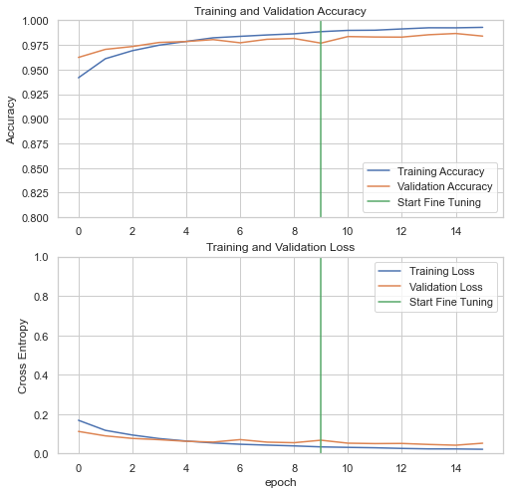

plot_metrics(history_fine)

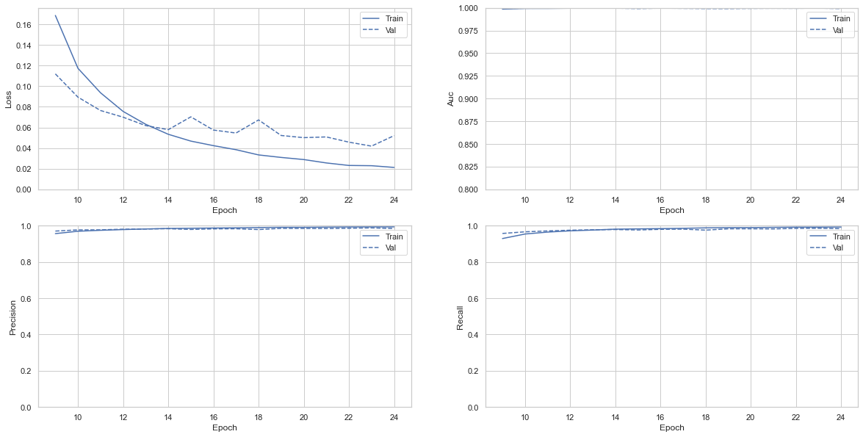

result = model.evaluate(test_dataset)

68/68 [==============================] - 151s 2s/step - loss: 0.0483 - tp: 2143.0000 - fp: 30.0000 - tn: 80482.0000 - fn: 33.0000 - accuracy: 0.9853 - precision: 0.9862 - recall: 0.9848 - auc: 0.9995

metrics = ["loss", "tp", "fp", "tn", "fn", "accuracy", "precision", "recall", "auc"]  
for i in range(len(result)):  
 print("{} : {}".format(metrics[i],round(result[i], 3)))

loss : 0.048  
tp : 2143.0  
fp : 30.0  
tn : 80482.0  
fn : 33.0  
accuracy : 0.985  
precision : 0.986  
recall : 0.985  
auc : 1.0

#Retrieve a batch of images from the test set  
image_batch, label_batch = test_dataset.as_numpy_iterator().next()  
predictions = model.predict_on_batch(image_batch)  
  
predictions = tf.nn.softmax(predictions)  
predictions = list(np.argmax(x) for x in predictions.numpy())  
  
print('Predictions:\n', predictions)  
print('Labels:\n', list(np.argmax(x) for x in label_batch))  
  
plt.figure(figsize=(10, 10))  
for i in range(9):  
 ax = plt.subplot(3, 3, i + 1)  
 plt.imshow(image_batch[i].astype("uint8"))  
 plt.title(class_names[predictions[i]])  
 plt.axis("off")

Predictions:  
 [12, 24, 10, 29, 24, 16, 19, 30, 16, 29, 35, 11, 31, 35, 11, 4, 24, 16, 11, 21, 35, 16, 16, 16, 35, 0, 4, 5, 4, 13, 35, 33]  
Labels:  
 [12, 24, 10, 29, 24, 16, 19, 30, 16, 29, 35, 11, 31, 35, 11, 4, 24, 16, 11, 21, 35, 16, 16, 16, 35, 0, 4, 5, 4, 13, 35, 33]

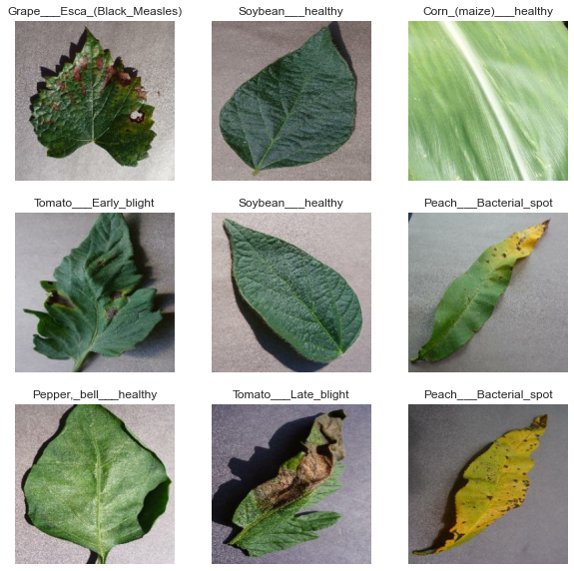

# Save Model

# save model in JSON format  
model_json = model.to_json()  
json_file = open("model_weights.json", "w")  
json_file.write(model_json)  
print("Model saved in JSON format!")  
   
# save training weights in h5 file  
model.save_weights("model_weights.h5")  
print("\nModel weights saved!")

Model saved in JSON format!  
  
Model weights saved!

model.save("inception_V3.0_fineTuning.h5")